Solar Calcs:
Whenever I say enter it would be nice to have this be a window in a GUI for manual entry or a radio button.

- Enter System Voltage (i.e 12, 24, etc…)

Enter Watts for each component. If you only have amps, multiply the amps by the system voltage to get watts.
Multiply the watts times 168 (hour in a week) to get the watt-hrs/week. whpw
Total up all the component watt-hr/week (whpw) to get the total watt-hrs/week. whpw

To get the amp-hrs/week (ahpw)divide the total watt-hrs/week by the system voltage. For example if the total watt-hrs/week is 2500 and the system voltage is 12V, the amp-hrs/week (ahpw would be:
ahpw$=\frac{2500}{12}=208.33$

- To determine the amp-hrs/day, (ahpd) divide the Amp-hrs/week (ahpw) by 7.
$ahpd=\frac{ahpw}{7}$
This is the total amps to run the system for 24 hours.

- If an inverter is needed you can total up all the watts required for all the components and multiply it by the system voltage. This will tell you the minimum size inverter you will need.
$$\frac{TotalWatts}{SysVoltage}= InverterWattMinimum$$

- Multiply the daily amp-hrs (amp-hrs/day) by 1.2 to account for any recharge inefficiency.
This is the amp-hrs/day (ahpd) you will use for all subsequent calculations.

SOLAR PANELS
- Now you can determine the number of solar panels. To calculate this, you will need to know sun-hours/day (shpd) as well as amperage output of the solar panels (PanelAmps). We like the system to be capable of fully recharging the system in a single day.

Sun-hrs per day.
Here’s a typical map for determining solar hours per day.
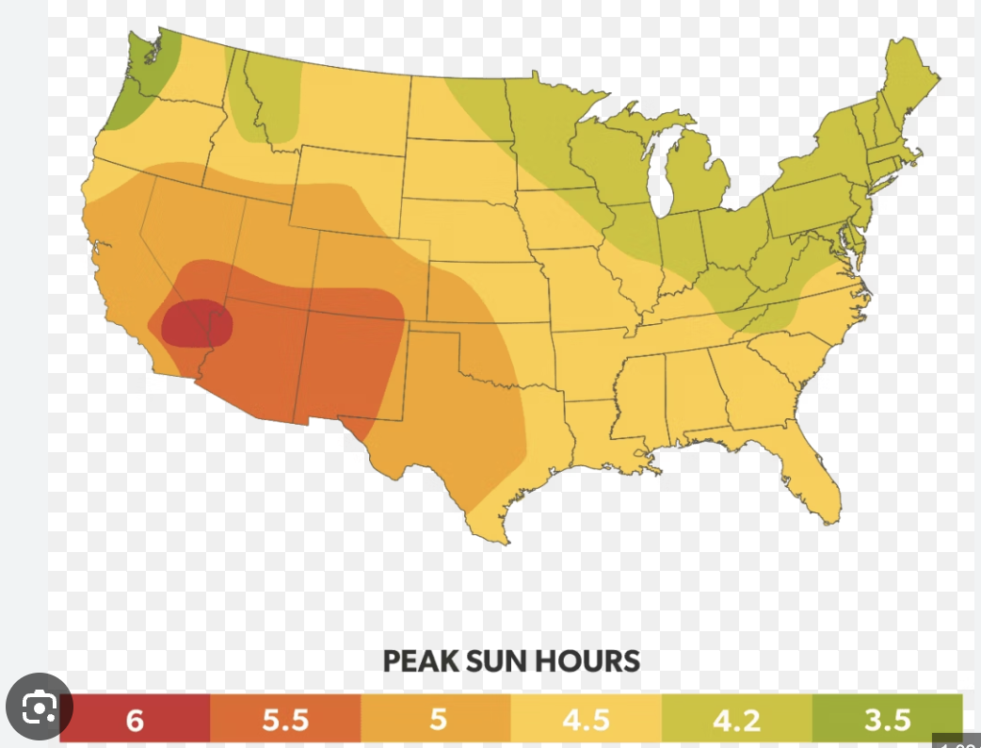

Solar panel output is found from the solar panel specs.

To find the solar amps required (SAR), divide the amp-hours/day (from 4 above) by the number of effective solar hours per day.

$SAR= ahpd/shpd$

To find the number of solar panels required (SPR), Divide the solar amps required by the PanelAmps.
$Solar Panels Required \left(SPR\right)=SAR/PanelAmps$

As you can’t have partial solar panels, you should round this number to the nearest whole number.

For example is, SAR =17 and PanelAmps = 9
SPR = 17/9 = 1.89. This should be rounded to 2.

BATTERIES
Now you can determine the number of batteries.
To calculate this you need to know the most consecutive number of sunless days (NoSunDays), the amp-hrs/day (number 4 above), your preferred discharge percentage (how far will you allow the batteries to discharge) BD%. No sun days is an estimate based on the local weather patterns.

Divide the ahpd by the BD%, this the required battery capacity per day (bcpd). For example if the ahpd = 109 and the BD% =80%
$bcpd=\frac{109}{0.80}=136.25 amps$

To find the required battery total (bcTot), multiply the bcpd by the number of sunless days.
$$bcTot=bcpd x NoSunDays$$
If we use the example above and predict worst case that the sun won’t shine for 6 days, the bcTot would be:
$bcTot=136.25 x 6=817.5 Amps$

To determine the number of batteries required, divide the bcTot by the battery-amp-hrs (bah).

$\# of batteries=\frac{bcTot}{bah}$

Realize that if you are using 6V batteries for a 12V system, you need to 6V batteries to make a 12V battery.

